Project Design Phase-II
Data Flow Diagram & User Stories

Date | 23-12-2025
Team ID
Project Name | MediConnect
Maximum Marks | 4 Marks

1. Data Flow Diagrams (DFD)

Overview
A Data Flow Diagram (DFD) illustrates how data flows within the MediConnect platform. It shows how Patients, Doctors, and Admin interact with the system, how data is processed, and where it is stored.

DFD – Level 0
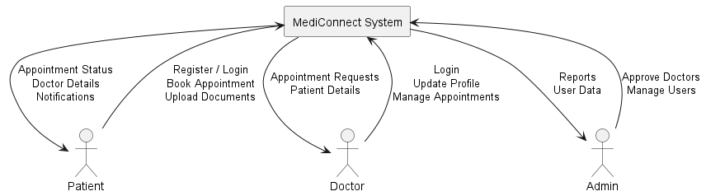

DFD – Level 1
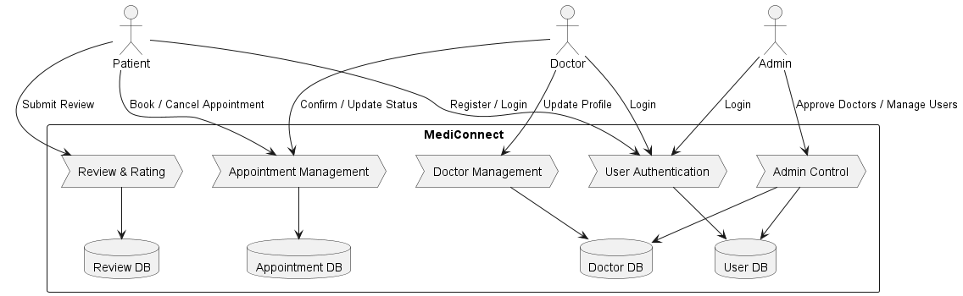

2. User Stories – MediConnect

User Story Table

User Type | Functional Requirement (Epic) | User Story / Task | Acceptance Criteria | Priority | Release
Patient | User Registration | As a patient, I can register and log in to the system | Patient account created successfully | High | Sprint-1
Patient | Doctor Browsing | As a patient, I can view and search doctors by specialization and location | Relevant doctors are displayed | High | Sprint-1
Patient | Appointment Booking | As a patient, I can book an appointment with a doctor | Appointment is saved and confirmed | High | Sprint-1
Patient | Appointment Tracking | As a patient, I can view my appointment status | Status updates correctly | Medium | Sprint-2
Patient | Document Upload | As a patient, I can upload medical documents | Documents are stored securely | Medium | Sprint-2
Doctor | Profile Management | As a doctor, I can update my profile and availability | Profile changes saved | High | Sprint-1
Doctor | Appointment Management | As a doctor, I can confirm or cancel appointments | Appointment status updated | High | Sprint-1
Doctor | View Patients | As a doctor, I can view patient details for appointments | Patient data displayed | Medium | Sprint-2
User | Review System | As a patient, I can submit a review after consultation | Review visible on doctor profile | Medium | Sprint-2
Admin | Doctor Approval | As an admin, I can approve or reject doctor registrations | Approval status updated | High | Sprint-1
Admin | User Management | As an admin, I can view and manage users | User actions logged | High | Sprint-2

Outcome
- Clear visualization of system data flow
- Well-defined user stories aligned with MediConnect features
- Supports scalable development and role-based access

